**EXP No.1**

**DDL Commands – CREATE, ALTER, DROP**

Output:

1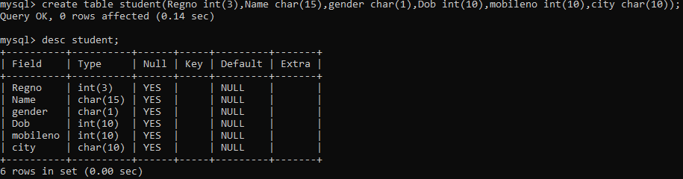

2.

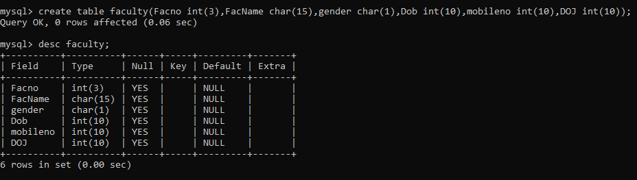

3.

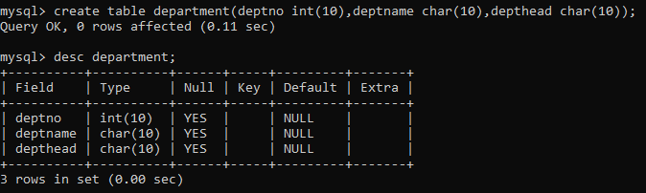

4.

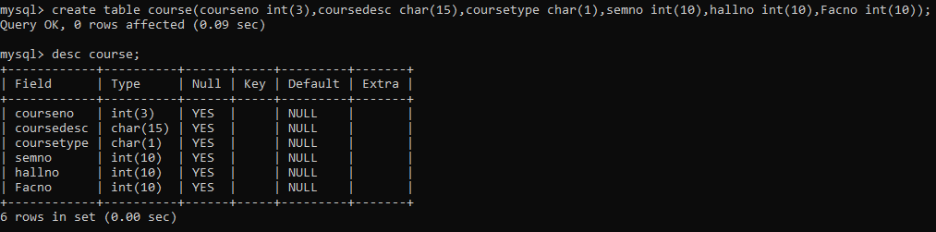

5.

